Thank you for your interest in attending the SIVANANDA ASHRAM AND YOGA RETREAT IN THE BAHAMAS, February 27th – March 2nd 2020, with Lee Ann Louis-Prescott and Jennifer Norber. The Ashram is located across the bay from Nassau, Bahamas, on one of the finest beaches in the world. It is truly an island paradise and a sanctuary of peace and natural beauty. With its pristine white sand beaches, crystal blue waters and five and a half acres of lush tropical gardens, the Sivananda Ashram Yoga Retreat provides the ideal environment for practice, rest, and rejuvenation. We hope you join us - Om Shanti

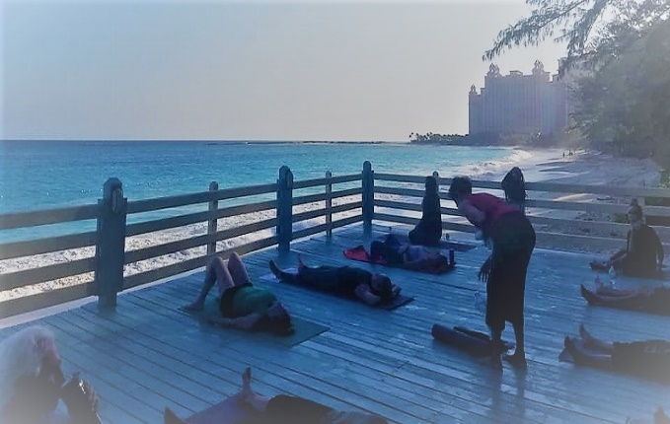
Entrance to ashram by boat Yoga Platform on the beach

Daily Ashram Schedule- lead by ashram staff:
- Yoga Asana and Pranayama Class: 8:00 am – 9:45 am and 4:00 pm – 5:45 pm
- Healthy Yogic Vegetarian Meals: 10 am and 6 pm
- Satsang (group meditation, chanting, & lecture) 6:00 am – 7:45 am & 8:00 pm – 9:45 pm
- Plus an extraordinary program of talks, workshops, and/or performances throughout the day.
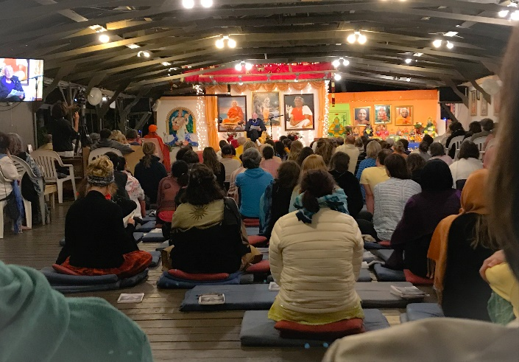 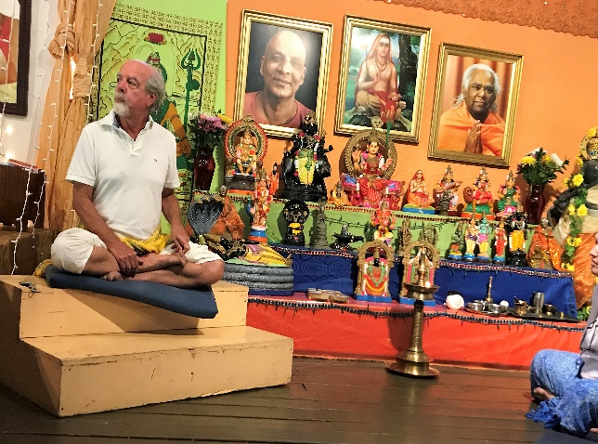 Evening Satsang Workshop with Ashram Senior Staff Member
Cost of the Trip:
Accommodations (Includes activities posted in the Ashram daily schedule above.)
Accommodations for 5 days and 4 nights vary from $356 plus tax for tent space (bring your own) to the Deluxe Beach Room for $1,520 plus tax for 2 people to MANY options in between. For lodging inquires or to book the trip please contact Chandrika at reservations.admin.bahamas@sivananda.org or call 1-866-559-5167 ext: 139
You can also go to: sivanandabahamas.secure.retreat.guru/program/yoga-vacation-program
and then enter the dates we will be attending to check out options.

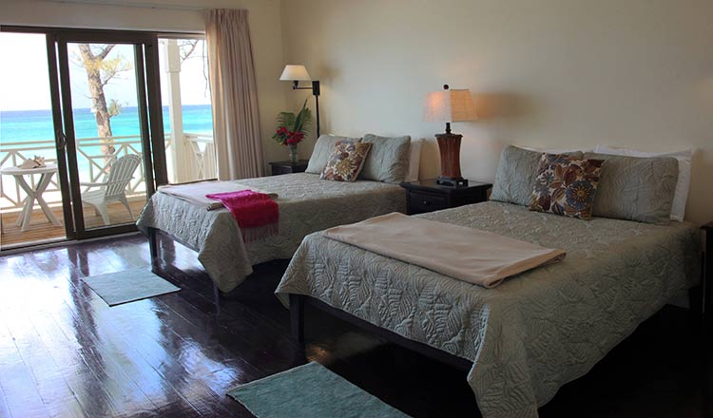 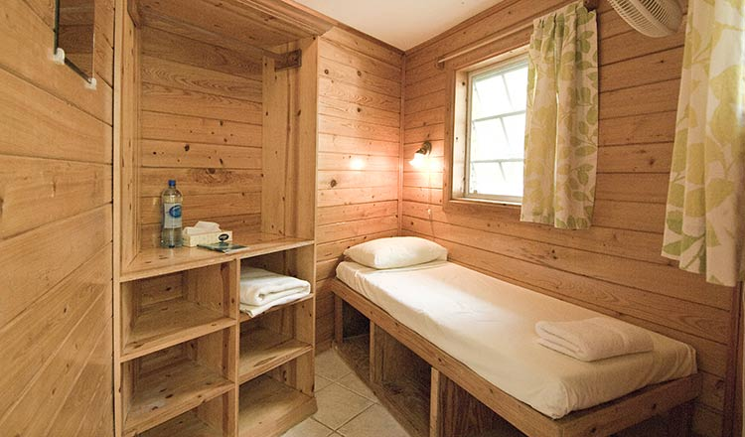
Deluxe accommodations Garden single accommodations

If 10 or more people register, we will all receive a 10% discount and if 20 people or more register we will all receive 15% off our lodging.
Last year all accommodations with an ocean view and with bathrooms in them sold out very quickly. Shared bathrooms are a quick walk from accommodations without a bathroom located in the room- however if a bathroom in your room is a must, book early.

Flight
If you would like to fly down with Lee Ann you can join her. Flight tbd – once it is scheduled you can book this flight through Karen at Meridian Travel 517 349-8800

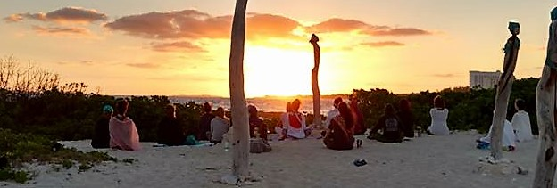
Sunrise meditation and kirtan
Other costs:
- Taxi to and from Airport and Ashram: Costs approximately $40.00 per way for one person.
- Depending on the Ashram’s Priests availability, we will try and schedule a Puja (sacred ceremony celebrating our journey). The cost will vary depending on the number of students. Between, $5.00 - $9.00 per student.
- Minimum Donation of $50.00 total to Lee Ann and Jen. If you can afford to pay more, you will be helping offset the costs for those who are unable to pay more at this time. We hope to expose as many students as possible to this experience, not make money so your minimum donation of $50.00 will help offset our personal costs. You will also receive…
  - 2 hour Workshop: All levels Sivananda style class and Satsang (Meditation and Sivananda Daily chants) at Yoga Center for Healthy Living in Brighton in November- date tbd.
  - A sunrise walk on the beach in the Bahamas with meditation and Kirtan. (Alternate activity will be planned if weather does not permit this.)
  - There may be other activities scheduled with our group as well- that will be designed to enhance and deepen your experience at the Ashram.

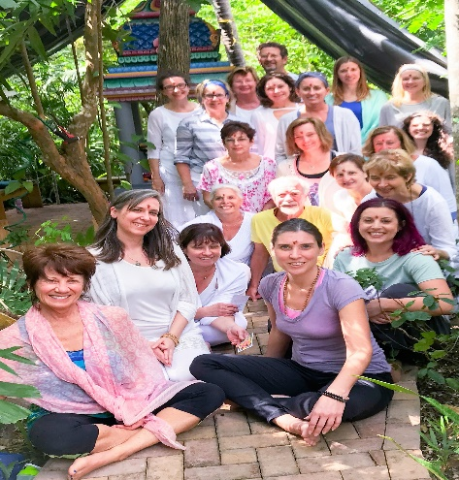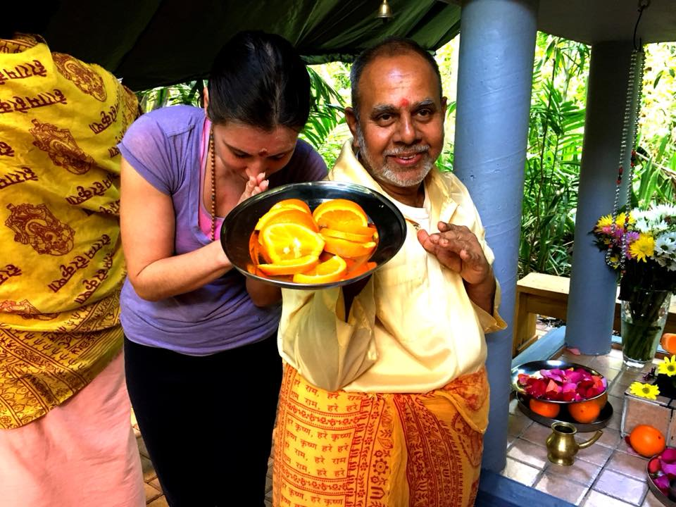
Vana (forest) Durga Temple- Puja
Optional costs:
  - Check with your cell phone carrier about an international plan and fees. There is FREE wireless internet at the Ashram.
  - Yoga mats are available for rental for $2.00 a day.
  - Treats at the Boutique, Bookstore and Health Hut in the Ashram.
  - There is free filtered water at the Ashram or you may purchase bottled water.
  - Well-being center with Ayurvedic consultations and body treatments.
  - If you do not have a passport, valid passports are required to travel to the Bahamas. Please make arrangements to acquire a passport 3 months before departure and have one that does not expire within three months after our trip.

Ashram Rules and other Guidelines:
Please note: This is a living, breathing, working Ashram. The consumption of alcohol, tobacco, and narcotics- both on and off the premises while you are staying at the ashram is considered to be a serious violation of the rules and will result in immediate expulsion!

With respect to its spiritual purpose, please wear modest clothing while at the ashram. Summer attire is completely appropriate; halter tops, low necklines, and short shorts are not. Bathing suits should be worn at the beach only. Worship spaces: Please wear modest clothing, with knees and shoulders covered.
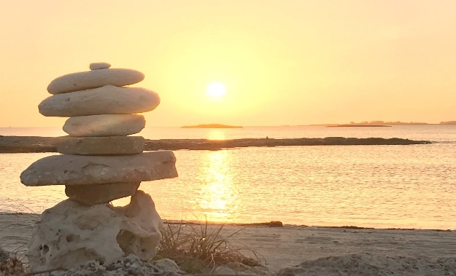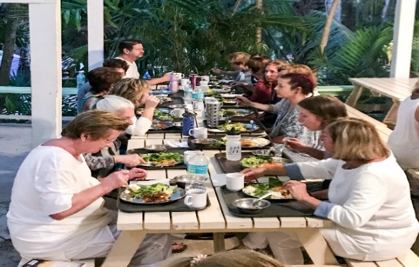
Sunrise Michigan Satsang at Dinner
Your Michigan Hosts:
Lee Ann Louis-Prescott Ph.D., E-RYT 500
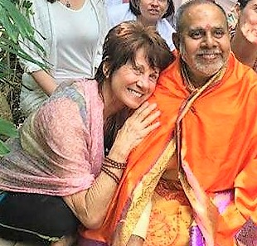
Lee Ann trained directly with Swami Vishnudevanada for over twenty years, including many times at this beloved Ashram. She received both her TTC/RYT 200 and TTC/RYT 500 under his direction. She has continued a lifetime love for yoga and studied under many other leading instructors such as Pattabi Jois, David Swenson and Deepak Chopra just to name a few. She is the owner and founder of Yoga Center for Healthy Living in Brighton, Michigan.

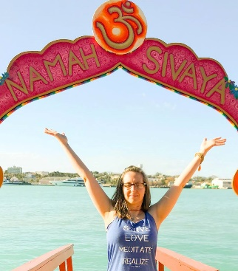
Jennifer Norber BSW, E-RYT 200
Jennifer completed her TTC/RYT200 with Lee Ann and went on to receive 2 additional certifications at the Sivananda Ashram in 2017 in Yoga Nidra and Yoga for Peace Ambassadors. She also studied Vedic and Tantric Mantra with Russill Paul for a year. In addition to teaching yoga in the Metro-Detroit area she has worked in Hospice for several years and as a Chaplain Resident at Beaumont Hospital. She feels inspired in her life by the Sivananda chant: Serve, Love, Meditate – Realize.

Friend us on Facebook and visit our event pages:

www.facebook.com/pg/yogacenterforhealthyliving/events/

http://yogacenterbrighton.com/retreats

